Improving the O2C process for an Online Retail Store
Project Report
By Zubair Gester

Table of Contents
Introduction: 2
Business background: 2
Current As-is process: 2
As-is process: 3
Pain points with As-is process: 4
To-be process improvements: 4
To-be process: 5
Key performance indicators (KPI’s): 6
Insights and recommendations: 6

Introduction:
This project involves an online retail store, particularly its Order to Cash (O2C) process, which currently faces several inefficiencies and productivity delays across its departments. I will demonstrate my skills at analyzing the existing business process, modelling the As-is process, identifying the pain points, suggesting my improvements to the process, modelling the To-be process, discussing Key performance indicators, and then finally give my full insights on how these changes would benefit the business and directly create value.
Tools used:
- Signavio - Process modelling
- Excel - KPI Dashboard

Business background:
An online retail company is facing delays in order fulfilment and recurring errors in invoicing, leading to dissatisfied customers and delayed revenue collection. The current Order-to-Cash (O2C) process is largely manual, with multiple approval steps, unclear handoffs between sales, warehouse, and finance teams, and inconsistent tracking of payments. This project aims to analyse the existing process (AS-IS), identify inefficiencies, and design an optimized process (TO-BE) that reduces delays, improves accuracy, and enhances overall operational efficiency.

Current As-is process:
The current Order-to-Cash process begins when a customer places an order through the e-commerce platform. The sales team manually reviews and approves the order before forwarding it to the warehouse for fulfilment. Once the order is picked, packed, and shipped, the finance team manually generates and sends an invoice to the customer. Payment is then tracked and confirmed by finance before the order is closed. The process involves multiple handoffs between departments and relies heavily on manual steps, which contributes to delays, errors, and limited visibility into order status across teams.

As-is process:
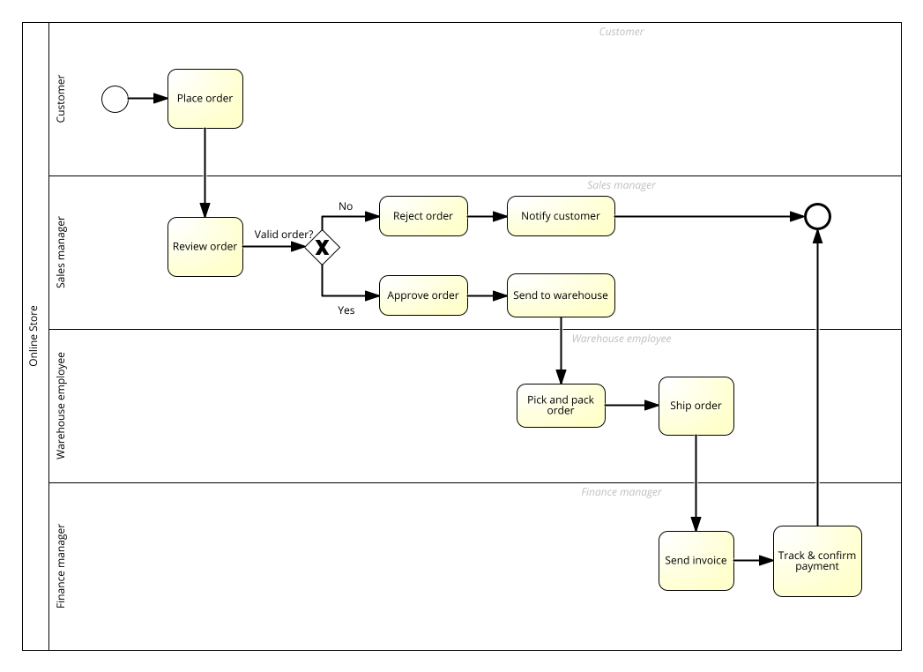
Figure 1: BPNM diagram of As-is process of the Order-to-cash process for the business

Pain points with As-is process:
- The process relies too much on manual steps which can cause delays in orders and is prone to human error
- There are too many unnecessary handoffs between departments, possible communication gaps and lengthy approval times
- Tracking of payments is inconsistent, manual and sometimes late

To-be process improvements:
- Automate tasks that are currently manual, such as automatically generating invoices in real time as soon as an order is shipped. Payment notifications can also be automatically sent to customers.
- Real time automatic order tracking that can be viewed by the customer and employees, regularly updating the order status in every department.
- The manual order approval system can be simplified by implementing business rules so that orders under or over a specific amount for example, can be automatically rejected or approved, reducing the work and time on the sales team, who only must manually check unusual orders, which are also automatically flagged by the system.
- Dashboard used by departments to see and update order status in real time, for clear hand offs.

To-be process:
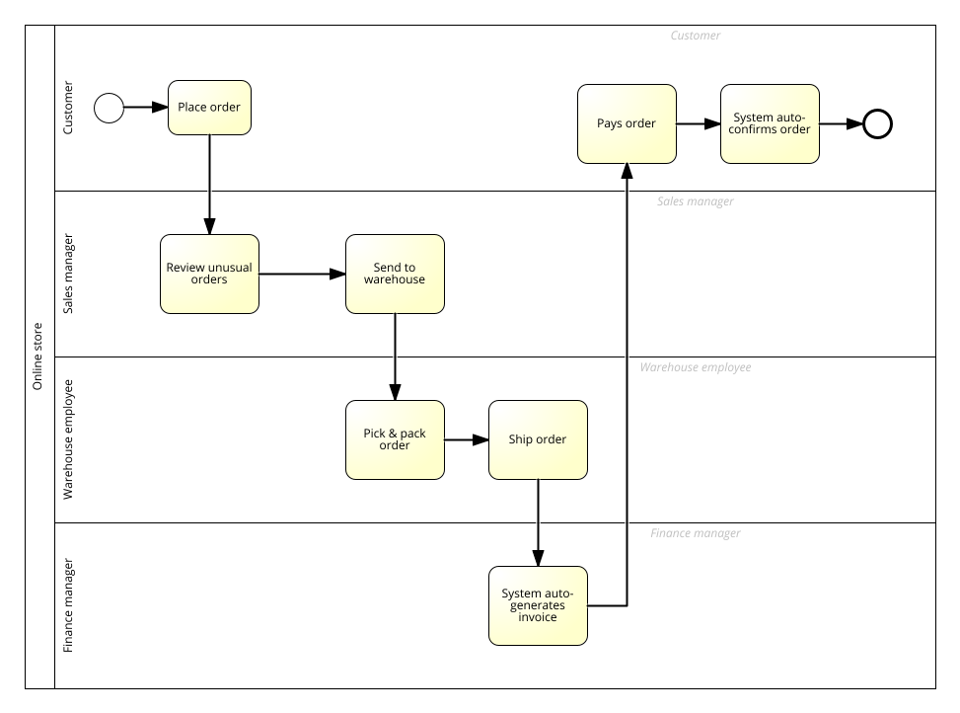

Figure 2: BPNM diagram of To-be process of the Order-to-cash process for the business

Key performance indicators (KPI’s):
The following are KPI’s for the Order-to-Cash process, that can be used to measure outcomes for the process improvements that directly bring the business value. KPI values are illustrative and created for demonstration purposes to show the potential impact of process improvements.

KPI | Current (As-is) | Target (To-be) | Notes
Order processing time | 5 days | 2 days | Faster approvals and automated tasks
Customer complaints | 10 per week | 2 per week | On time delivery and less errors
Invoice accuracy | 80% | 99% | Auto-generation reduces human errors
On-time delivery date | 75% | 97% | Faster handoffs and shipments

(NB: Full KPI Dashboard provided as separate Excel Sheet)

Insights and recommendations:
The To-be process then clearly demonstrates real-time order status automatically updated by the system, automatic order notifications and auto-generating invoices. Also, automatic confirmation of order payment. It also demonstrates clear business rules as the system auto-approves most orders based on rules specified, leaving only unusual orders to be manually reviewed by the sales team, saving time and preventing delays. Auto-invoicing eliminates manual errors, improving invoice accuracy from 80% to 99%. Reducing approval steps will cut order processing time by 60%. Tracking KPIs in a dashboard allows departments to react immediately to delays.
All these process improvements benefit the business by removing manual tasks which can cause order delays and are prone to human errors, therefore saving costs to the business, improving employee productivity and ultimately ensuring orders are shipped and completed faster, improving customer satisfaction and repeating purchases, therefore directly creating value to the business.

